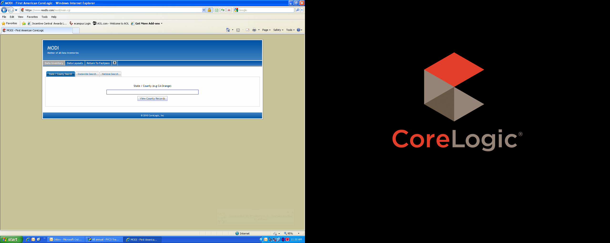

This box can stay as is.

Perhaps these tabs can have departments: Data QA/QC, Transactions, Securities & Servicing, Instructions, Acronyms/Glossary, FAQ/Frequently reported issues list.

Add an “Advanced search” button so users can enter more detail if they are looking for something specific, such as field, issue type, or product affected either county specific or nationwide.

This can stay as is.

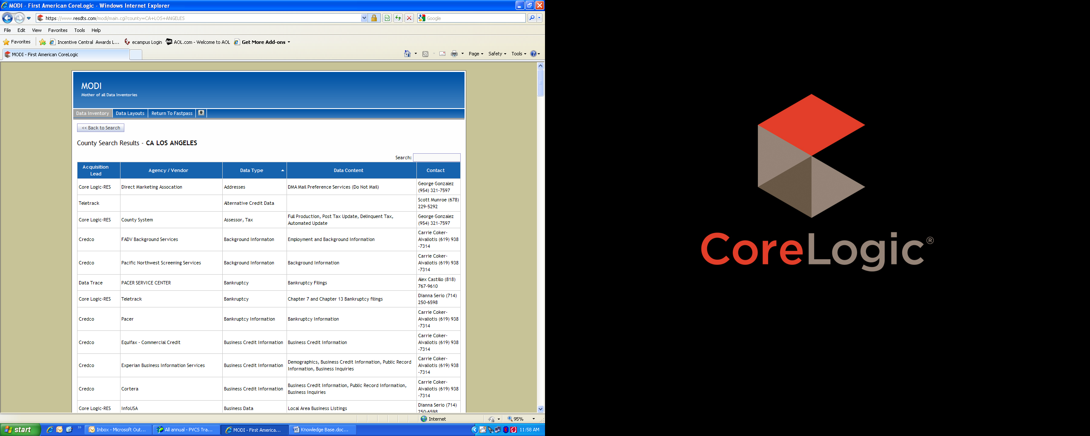

Would be nice if we could filter or sort this list.

These fields can be listed as the same shown in Sharepoint/Knowledge Base. (See below)

Add link to each list item to open for details.

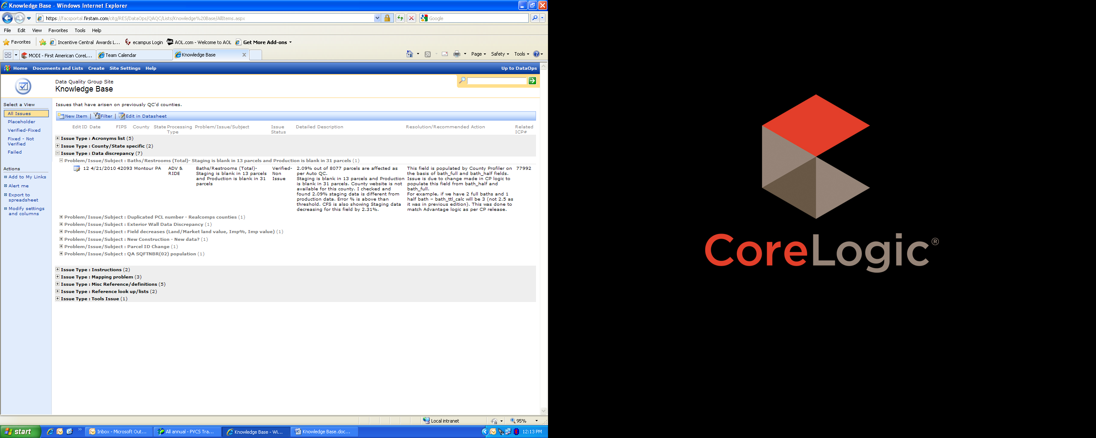

List should return most recent with a limit on how many returned. Ability to search archived items is necessary.

List from page 1 should contain “quick view” fields as shown here.

See sample of entry form on SharePoint KB. Only a handful of analysts/supervisors will be authorized to add/approve/delete content, but all users must be able to complete entry form.